
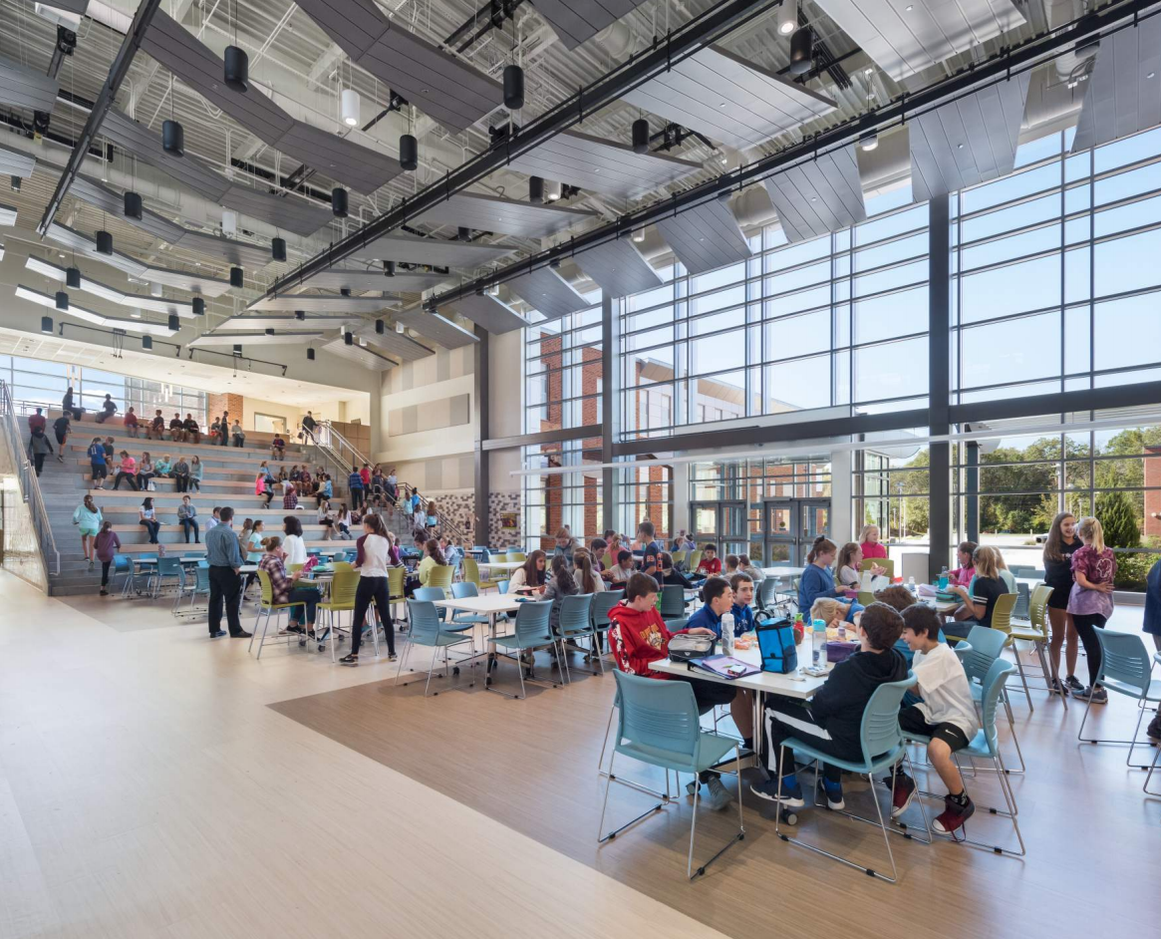

-------------------------------------

Massachusetts School Furniture Exhibition
2020
-------------------------------------
Thursday, May 7th
10:00 AM – 5:00 PM
DCU Center North Exhibit Hall
50 Foster St, Worcester, MA
Calling all School District Personnel, Procurement Officers, Architects, and Designers!
Massachusetts is currently undertaking approximately $1B worth of school construction per year in the public K-12 market with a combination of a state-funded grant program and local funding.
The 2nd annual exhibition hosted by the Association for Learning Environments (A4LE) Northeast Region is a one stop showing of the latest school furniture products from furniture manufacturers and furniture dealers.
Admission to attend the event is FREE to all school personnel, public officials, and members of the design community. The format is open house … visitors come and go over the course of the day.
Exhibitors interested to reserve a booth must register and pay a fee. Click here to register.
For more information please visit A4LE’s website or contact Carla Cummins at carla@a4le.org

LESTER J. GATES MIDDLE SCHOOL
Scituate Public Schools
Scituate, MA

